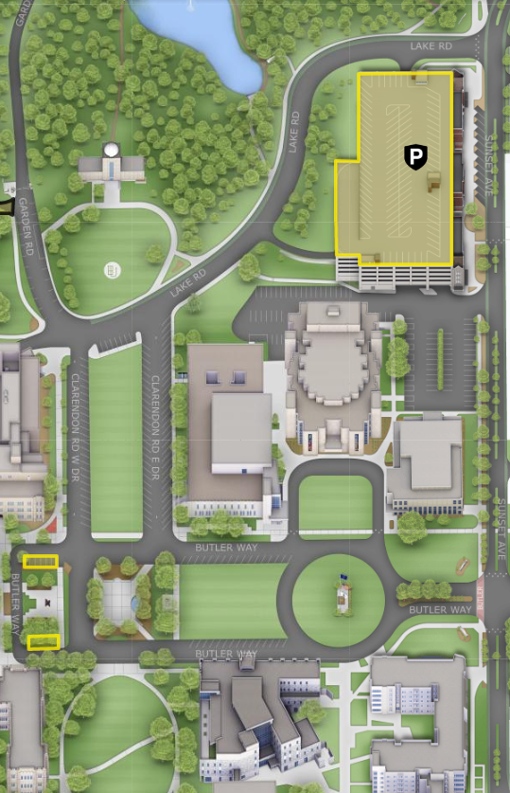
Dugan Hall
Clowes Hall
Lilly Hall
Lacy
School of Business
N
Parking Garage
Directions from the Butler Parking Garage to new Lacy School of Business
Butler University’s Parking Garage is located at 4682 Sunset Avenue, Indianapolis, IN 46208.
The Lacy School of Business (Dugan Hall) is located at 625 Butler Way, Indianapolis, IN 46208.

Via the South Exit [Green elevator] (behind Clowes Memorial Hall)
If exiting the parking garage via South exit [green elevator] (behind Clowes Memorial Hall), turn left and walk toward Sunset Avenue. Turn right and utilize the cross walk and continue on the sidewalk parallel to Sunset Avenue. At the corner of Sunset Avenue and Butler Way, utilize the crosswalk until the next corner of Sunset Avenue and Butler Way. Turn right and continue on the sidewalk parallel to Butler Way. (The Fairview House should now be on the left.) The second building on the left is the new Lacy School of Business building, and the entrance to the main lobby will be the second set of stairs on the left. The address for the new Lacy School of Business building (Dugan Hall) is 625 Butler Way.

Via the East Exit [Yellow elevator] (facing Sunset Avenue)
If exiting the parking garage via the East exit [Yellow elevator] on Sunset Avenue, turn right and continue walking down the sidewalk parallel to Sunset Avenue. Utilize the cross walk and continue on the sidewalk parallel to Sunset Avenue. At the corner of Sunset Avenue and Butler Way, utilize the crosswalk until the next corner of Sunset Avenue and Butler Way. Turn right and continue on the sidewalk parallel to Butler Way. (The Fairview House should now be on the left.) The second building on the left is the new Lacy School of Business building, and the entrance to the main lobby will be the second set of stairs on the left. The address for the new Lacy School of Business building (Dugan Hall) is 625 Butler Way.
Pharmacy &
Health Sciences

